Assignment sql join clause

1 SELECT * FROM super_hero_powers

LEFT JOIN heroes_information ON super_hero_powers.column_name = heroes_information.column_name;

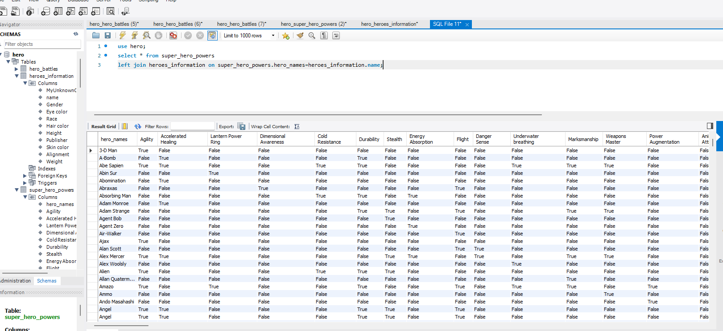

2 Take super_hero_powers and do a right join with hero_battles on the name columns. Note that the name column is hero_names on the super_hero_powers table.

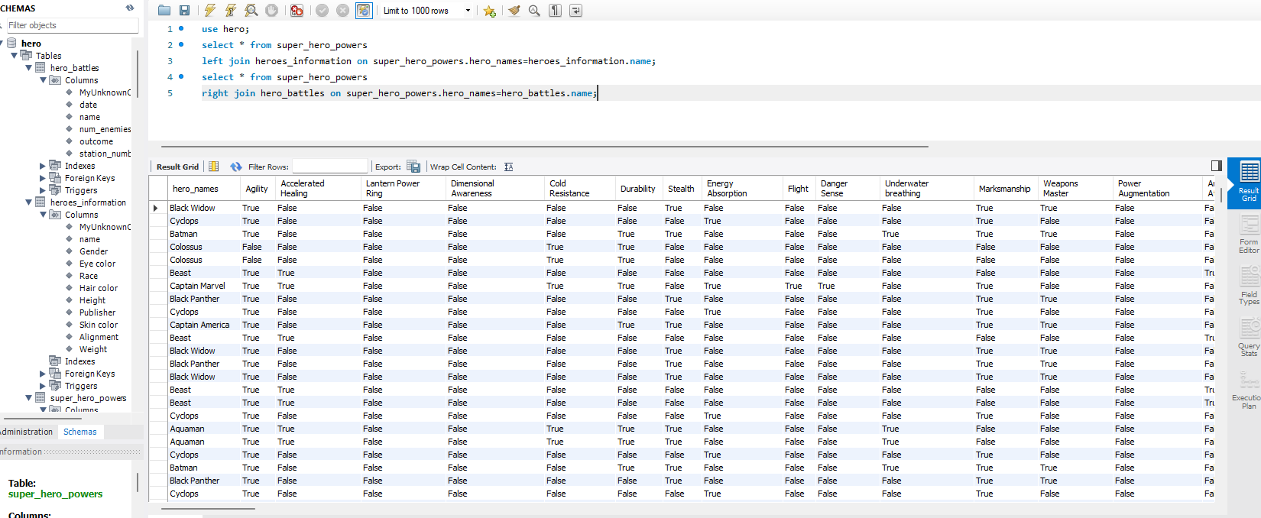

3 Select all the female heroes from heroes_information and stack that name result on top of all the heroes who have accelerated healing from the super_hero_powers table. Only return the name columns

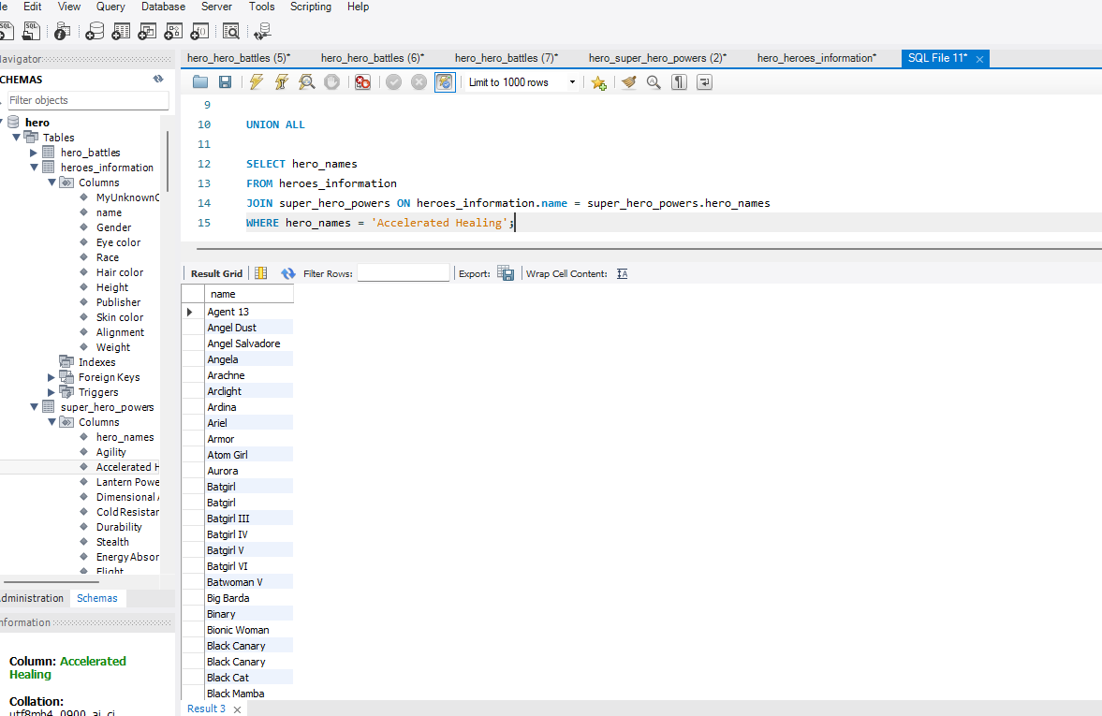

SELECT name FROM heroes_information

WHERE Gender = 'Female'

UNION ALL

SELECT hero_names

FROM heroes_information

JOIN super_hero_powers ON heroes_information.name = super_hero_powers.hero_names

WHERE hero_names = 'Accelerated Healing';